

*INTERNET FOR ALL – PROJECT LOON*

*Akash James*

Department of Computer Science Engineering, Reva Institute of Technology and Management.

akash.james2096@gmail.com

**ABSTRACT--** Connectivity to the Internet is a vital technological requirement. It’s arguably one of the best and most transformative technological advancements of our species. However, approximately 4.3 billion people who still live in rural and remote regions where telecommunication is scarce or absent are not gifted with a connection to the World Wide Web. These are mainly due to terrestrial hurdles like dense forests, deserts, mountains, etc. These restrict construction of cell towers, radio antennas and other connectivity based infrastructure. This is a problem, isn’t it?

To eliminate this problem, straight out of Google X lab, comes another ambitious project to bring everyone up to power with the Internet. Named *Project Loon*, it focuses on a simple idea of releasing a swarm of balloons up into the stratosphere that would beam connection speeds as fast as the modern day 3G networks or even faster. This opens a wide range of possibilities that include connectivity to remote and rural areas and providing instant connectivity to places prey to natural disasters. It may sound absurd to a few, but this is one project that is tried and ready to be launched on a global scale. This abstract barely scratched the surface. There is more to how this works and the potential it holds.

**INDEX TERMS—** Google X Lab, Internet Connectivity, Rural Education, Loon Internet.

----------------------------------------------------------------------------*******---------------------------------------------------------------------------

1. **INTRODUCTION**

**I**nternet has opened a wide range of possibilities. It has enhanced the modern technological lifestyle by a huge milestone. Exchange of information from one place to another cannot possibly be better without Internet. The internet always keeps evolving effortlessly, but one problem persists always: Internet restricted to a few, not available for all. Only 40% of the total population have access to an internet connection. The rest usually belong to the rural and remote areas where telecommunication infrastructure with access to internet cannot be easily established. This is where the people at the secretive *Google X Lab* gave birth to *Project Loon-* A revolutionary idea which was centralized on providing connectivity to remote areas in a cheap and efficient manner. All of this by just using *Balloons* floating in the stratosphere beaming 3G like network. It was named ‘Loon’ as the very people at google found the idea of providing 5 billion people with Internet as ‘crazy’. The main people behind the initiative are *Rich DeVaul*, chief technical architect, *Mike Cassidy*, the project leader and *Cyrus Behroozi*, a networking and telecommunication expert.

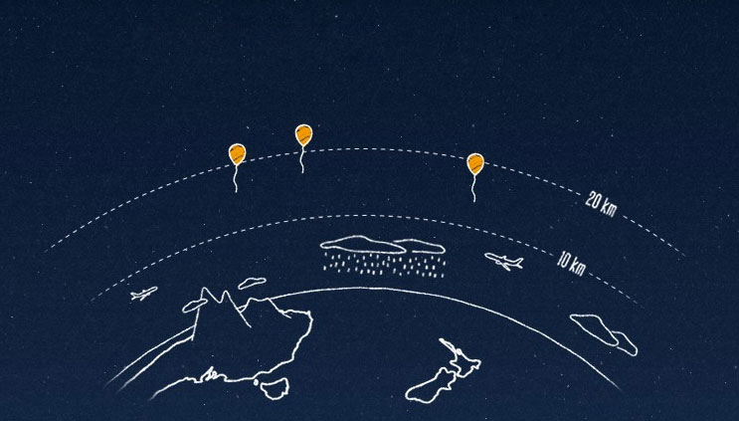

1. **PROJECT LOON**

It all began when Google decided to acquired Space Data Corp., a company that manufactures and sends balloons high up in the atmosphere carrying small base stations to help the oil companies and their trucks in southern United States, but didn’t do so. The unofficial development on Project Loon began back in 2011 at the Google X lab. This led to the invention of high-altitude stratosphere balloons, equipped with a radio antenna, GPS system, sensors and other equipment that was designed to stay up for long durations of time and travel around beaming signals down at the receivers. The first experiment was carried out in 2013 in New Zealand. 30 balloons brought connectivity to about 50 people and the balloons travelled in an area of 10,000 km2. It proved to be successful and it was plausible for a global level launch. To understand the functioning and technology gone into Project Loon better, let’s break it down into subtopics:

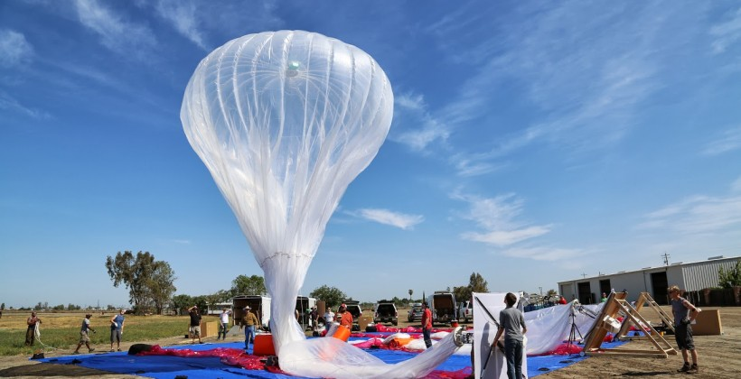

1. Equipment Used:

Each balloon is helium filled, enabling to reach Stratospheric heights. The balloons use an envelope developed by Raven Aerostar, that protect the inner *balloonettes* from high altitude damage. It is made up of polyethylene, the same stuff used to make Garbage bags! The balloonettes deflate and inflate to change altitude accordingly. It consists of a small box that houses electronic circuitry, ‘Rocket M2’ to communicate with the ground antennas and other balloons, radio antenna, and lithium ion battery to keep everything powered up even through the night. Solar panels are used to charge the batteries. It consists of a parachute to aid in a safe landing during a mishap. However, there is no propulsion system onboard the balloons.

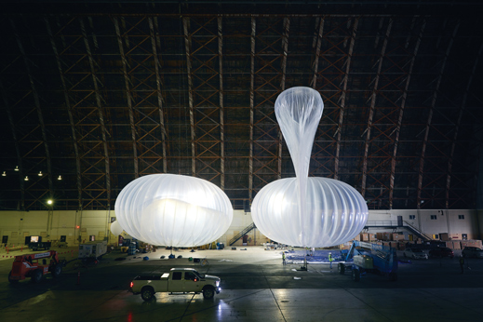

1. Driving Technology:

As mentioned earlier, these balloons operate in the stratosphere between 18km - 25km. This is well over clouds, storms and commercial airplane paths. Google claims that the turbulence is less as well in the stratosphere, hence making it ideal for the balloons. Right now the balloons use unlicensed 2.4 and 5.8 GHz ISM bands to provide connectivity. There are several questions that arise regarding connectivity and path of travel of these balloons:

*How to the balloons travel from one point to another without being drifted away?*

The stratosphere consists of layers of winds travelling in different directions at different directions. By monitoring wind patterns, the altitude of the balloons can be adjusted to catch particular path of winds to travel in the desired direction.

*How is stable connectivity ensured?*

The idea is to have a large swarm of balloons that communicate with each other such that there are several balloons passing over an area to ensure stable connectivity.

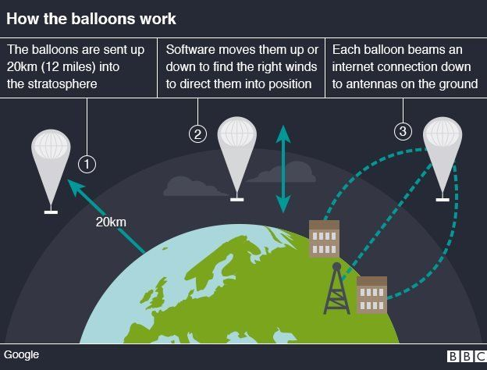

The balloons are using nature to its advantage to travel from place to place using the stratospheric winds and being powered using solar energy.

1. **APPLICATIONS OF PROJECT LOON**
2. Rural Areas for Education:

Areas with less connection with the outside world are plagued with lack of information and education. This can be a thing of the past with Loons. It can help bring internet to the most remote places helping the upcoming children to be educated and reduce illiteracy levels.



1. Help Farmers:

Farmers can access weather information helping them analyze and implement their cultivation techniques to maximum advantage. Also, it can help farmers learn newer and more efficient ways of cultivation to boost crop yield.

Areas affected with natural disasters or other mishaps can have the Balloons as emergency connectivity lines helping them assess the situation and take appropriate measures.

1. **FLAWS AND BACKDRAWS**

As any other upcoming technological breakthrough, Project Loon faces hurdles as well. Some of them are as follows:

1. Vulnerability of Balloons in the stratosphere:

In order to make the balloons light, polyethylene in its production which can easily be damaged. There are several reports of Balloons crashing due to ruptures in the material.

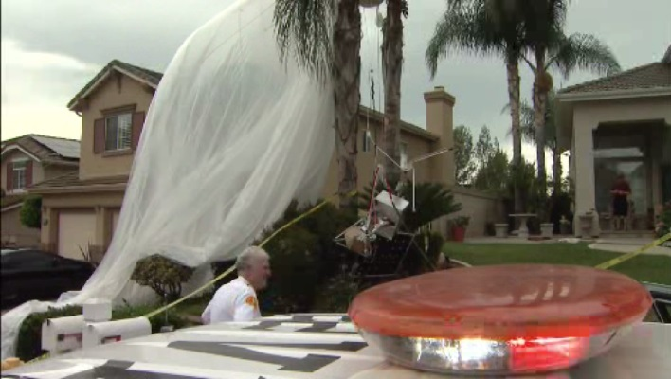

1. Providing a stable connection:

Though google has a brilliant algorithm implemented to provide an equal and stable connectivity plan, it still isn’t fool proof. This will always remain a big hurdle. Nature can change and the wind paths can be erratic.

1. Recovering worn out balloons:

Worn out balloons can land anywhere and everywhere. Recovery can be a daunting task as it can require extraction of these balloons from inaccessible locations. Also, since the balloons don’t have a very long lifetime, they will require frequent service halts.

1. **CONCLUSION**

*Project Loon* is very promising and can be the next big technological break-through if implemented globally. It has a wide variety of applications which give more meaning to the word ‘Internet’. Yes, it does have its hiccups, but the people at Google are working really hard and they have come really far. Once implemented globally, connectivity issues will no longer prevail.

References:

1. Wikipedia: https://en.wikipedia.org/wiki/Loon
2. 10 breakthrough technologies 2015: https://www.technologyreview.com/s/534986/project-loon/
3. Neighbours shocked when Giant Google Balloon falls from Sky: http://sanfrancisco.cbslocal.com/2015/09/12/neighbors-shocked-when-giant-google-loon-balloon-falls-from-sky-onto-quiet-socal-street/
4. Project Loon: http://www.google.com/loon